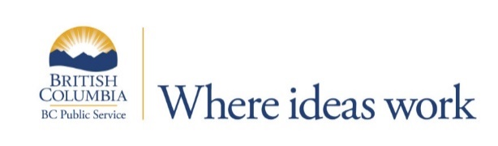
Ministry of Forests, Lands, Natural Resource Operations and Rural Development
Fort St John or Dawson Creek
Indigenous Relations Team Lead
$66,675.12- $83,659.51 annually
This position is also posted as an Scientific/Technical Officer 27(RES) under Requisition 73447
Make a difference in this rewarding career opportunity
BC Timber Sales (BCTS) manages about 20 per cent of the province’s allowable annual cut for Crown timber, generating economic prosperity for British Columbians through the safe, sustainable development and auction of Crown timber.
BCTS also supports government’s commitment to true, lasting reconciliation with First Nations in BC as we move toward fully adopting and implementing the United Nations Declaration on the Rights of Indigenous Peoples and the Calls to Action of the Truth and Reconciliation Commission.
The Indigenous Relations Team Lead works within the BCTS business area and across business areas and is instrumental in developing and maintaining positive relationships with Indigenous Peoples to advance BCTS’ business principle dedicated to true and lasting reconciliation. The position supervises Indigenous Relations Liaison and leads engagement and reconciliation efforts with Indigenous Peoples. The position also facilitates more complex legal consultation processes with Indigenous Peoples and leads and supports the negotiation and implementation of business-to-business and relational agreements that contribute to effective and durable relationships with Indigenous Peoples. The position leads activities where a First Nation overlaps with multiple business areas and in situations involving more complex First Nations interests or initiatives.
The BC Public Service offers a healthy work/life balance, excellent benefits, including one of the best pension plans available, and a variety of opportunities for career learning and development. Regular, full time Professional Employee Association members are also entitled to 7% allowance in Lieu of Overtime Shiftwork and Standby (taken as time or money), have a 35 hour work week, and 4 weeks’ annual paid leave entitlement. To find out more, explore What the BC Public Service offers You
The BC Public Service is committed to creating a diverse workplace to represent the population we serve and to better meet the needs of our citizens. Consider joining our team and being part of an innovative, inclusive and rewarding workplace.
Qualifications for this role include:
- Degree in a field related to the work of the program area and 3 years of experience related to natural resource or Indigenous Peoples relationship management OR a Diploma in a related field and 4 years of experience.
- Experience in successfully negotiating/mediating solutions with Indigenous Peoples’ communities.
- Must possess at minimum a valid Class 5 B.C. Driver’s License that does not limit or restrict the ability to conduct the duties of the job.
For more information and to apply online by January 10, 2021, please go to: https://bcpublicservice.hua.hrsmart.com/hr/ats/Posting/view/73448

